Broward County Animal Care & Adoption

Where to go when you FIND a pet or have a

pet you DO NOT have legal ownership of:

2400 Southwest 42nd St, Fort Lauderdale, FL, 33312
(954) 359-1313 ex. 2
http://www.broward.org/animal
Monday (Dispatch ONLY)
Tuesday-Sunday (11 am – 5:00 pm)

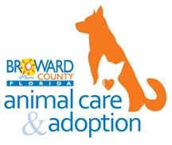
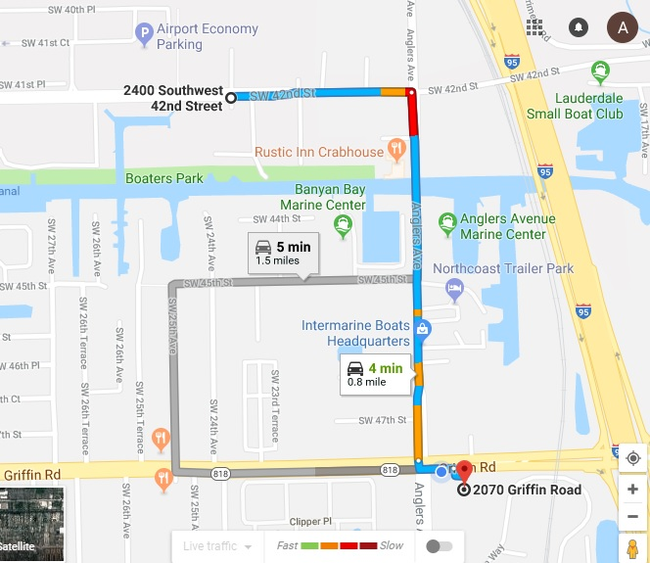

Call their dispatch line to have an Animal Care Officer pick-up the pet if you are unable to drop off during hours of operation. Please be aware they will not pick up in our parking lot. (Broward County Only)

Harboring of Stray Animals: Section 4-23
A person cannot harbor any stray animal unless it is reported to Animal Care within 48 hours of finding the animal. Once notified, Animal Care may take the animal and place it in the shelter. Refusal to surrender the animal may result in an additional violation of this ordinance.

The Humane Society of Broward County is a non-for-profit organization funded solely by friends like you to intake owned animals.
Broward County Animal Care and Adoption receives government funding for stray, found, or abandoned animals and therefore has jurisdiction over them to try to find their owners or place them up for adoption.

Driving Instructions

• Take Anglers Ave northbound to SW 42 St
• Turn left on to SW 42 St
(The destination is on the left)

IF YOU ARE GOING TO HOLD ONTO THE PET:

- Contact Local Animal Control - File a found pet report with a picture if possible. All owners looking for their pets are encouraged to keep checking through shelters’ lost and found listings.

- Get pet scanned for microchip at a Vet or Animal Shelter.

- (If the pet has a microchip) Go to Petmicrochiplookup.org, type the chip # in, and it will tell you which company to call. If the animal is registered, the company can contact the owner for you.

- Make posters and put them everywhere you can. Pet Stores, Vet Offices, Phone Poles, Dog Parks, Parks… Hand out flyers to neighbors and your mail carrier.

- Make sure to ask for PROOF OF OWNERSHIP if someone shows up to claim the pet. (Photos, Vet Records, Rabies Info or Microchip Info)

- Check the ‘Lost and Found’ section on www.craigslist.org, social media sites like Facebook and Twitter, and apps such as Nextdoor and Finding Rover for lost pets in the city that the pet was found in, etc.
DO NOT try to introduce the found pet to your personal pets and limit contact until the animal has been seen by a veterinarian. Animals can harbor many diseases and illnesses that are not visible until seen by a veterinarian.

**PLEASE DO NOT GIVE THE PET AWAY TO JUST ANYONE, SOMEONE MAY
BE SEARCHING VERY HARD FOR THEIR LOST PET**

S:\1 All Customer Service Forms\ALL FORMS\ANIMAL ADMISSION FORMS\Information Handouts

