Cat Scratching Pad
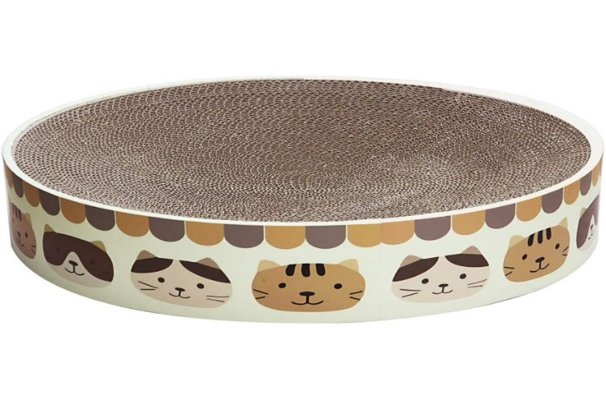
Cats need to scratch. It relieves stress, removes old claw sheathes and just feels good. It also relieves boredom while they are here at the shelter!
One scratching pad = 2 hours of community service
MATERIALS:
- Cardboard boxes (3 large or 5 medium size boxes)
- Duct tape
- Box cutter or hefty pair of scissors
- Cat nip

INSTRUCTIONS:
- Cut cardboard boxes into 4" strips.
- Roll a strip of cardboard up very tightly. When you get to the end of it duct tape it to another strip of cardboard. Continue doing this, rolling, and taping until your scratching pad measures at least 16" across. This way the cat can sit on top of it and scratch.
- Once it’s about 16 inches wide put colorful duct tape around the base and then sprinkle with cat nip. That will attract the cat.
Humane Society of Broward County * humanebroward.com *
Contact Education Department for credit (954) 266-6815

